**Overall Art Style**

The Low-poly art style of this picture can be a good guideline for the art. The buildings in the background would also be a good thing to take inspiration from. The color palette however should be ignored when using this picture as a reference. It seems like a hellscape and that’s not the artstyle we are going for.

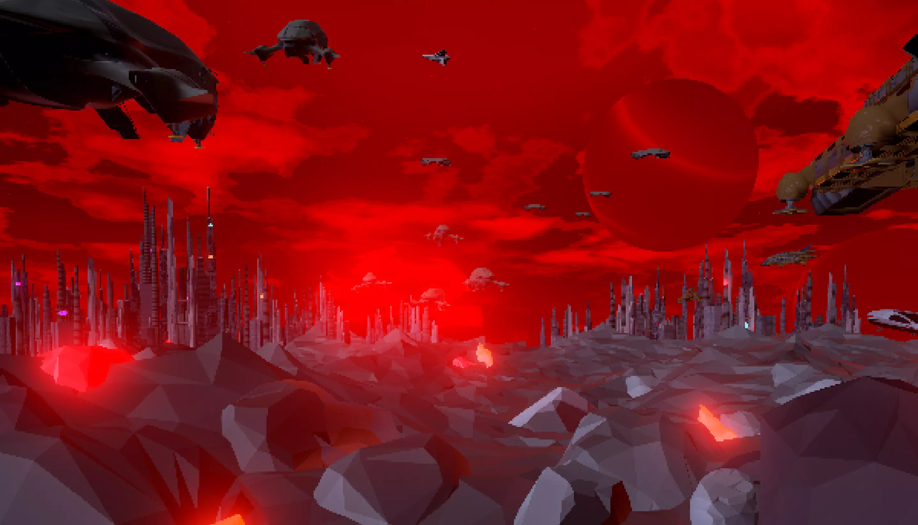

The colors in this one are a good reference for what we are trying to achieve with the bright colors.

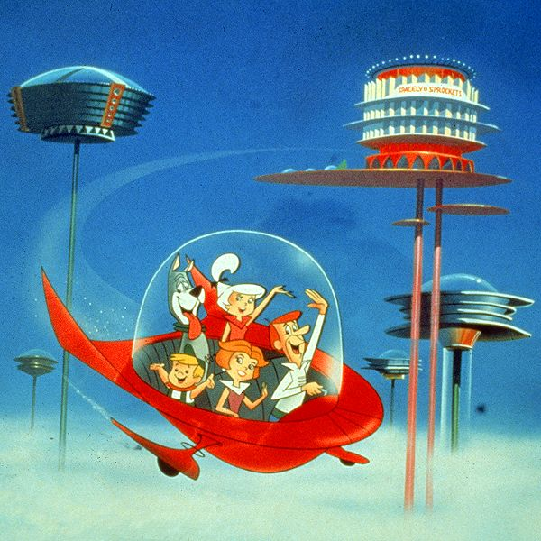

The dome shape in this picture can be used as the dome in the Pineapple Pain Penitentiary. This also may be a good reference for color when we don’t want the bright bold colors and want more of a lighter color palette.

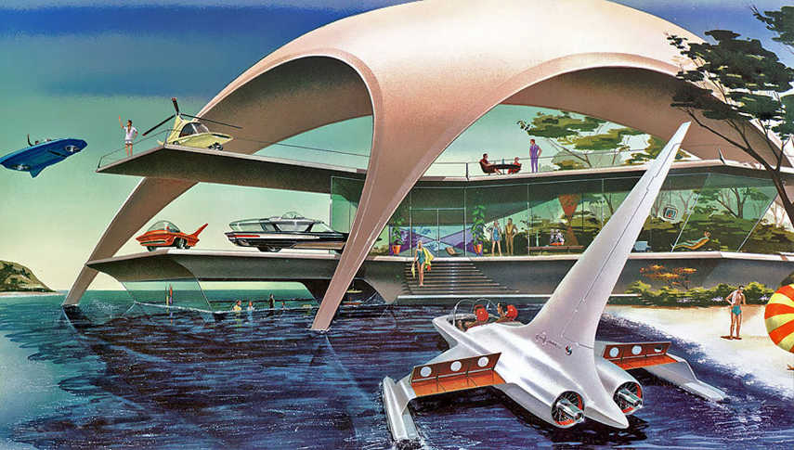

The round circular patterns of the house are a good reference for buildings. Like the last picture would also be a good reference when we want a lighter color palette.

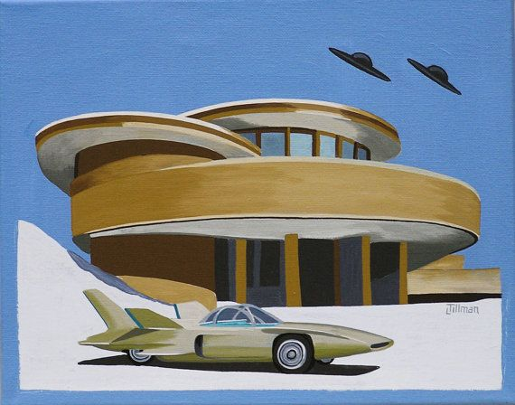

A possible reference for architecture for objects that are not spherical

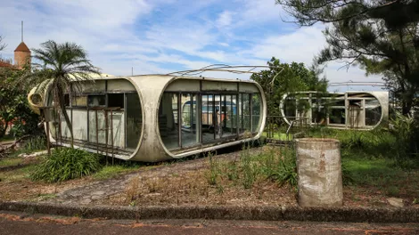

The track from this game would be a good reference for the track in our game.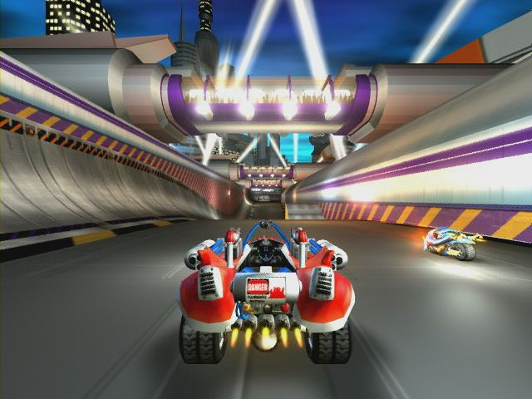

These images would be great for floor patterns for the Pineapple Payload maps since those maps tend to be more open, arena style maps.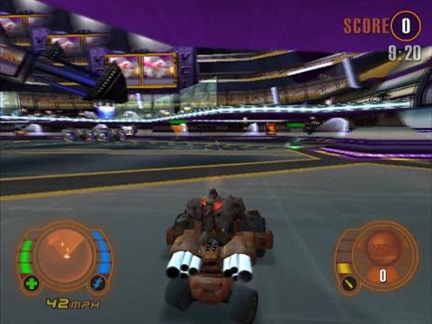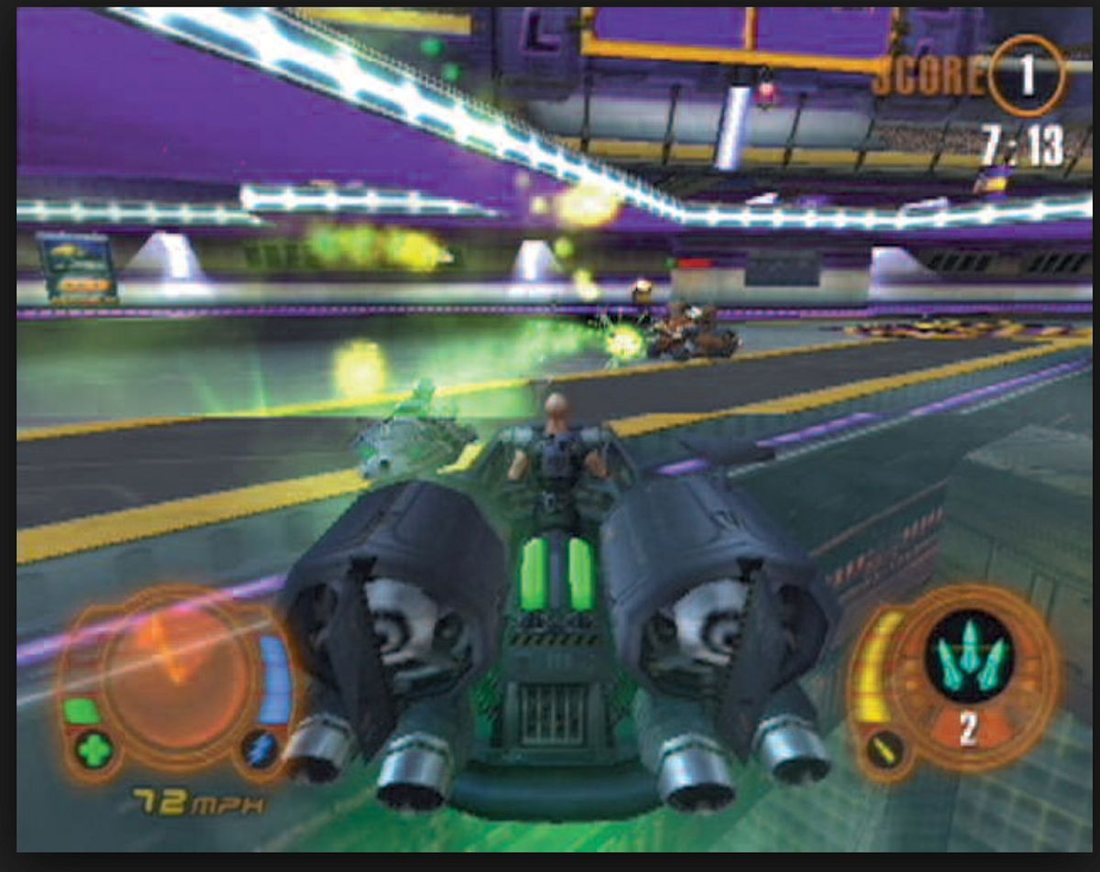

**Specific Objects**

Boost Pads

Something that looks like this but matching the color palette of the race track

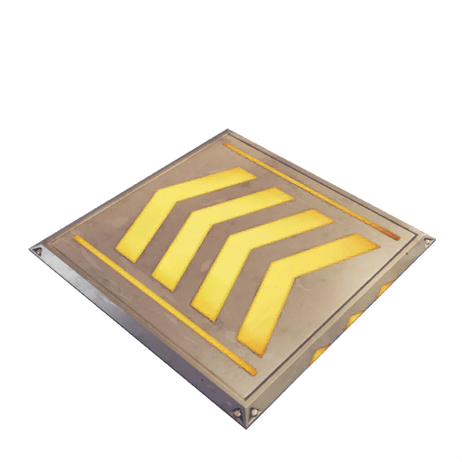

Jump Pads

Looks the same as the boost pad except blue and the arrows point inward.

Ramps

Something that looks like this in shape but with the texture matching that of the actual track that it’s used on.

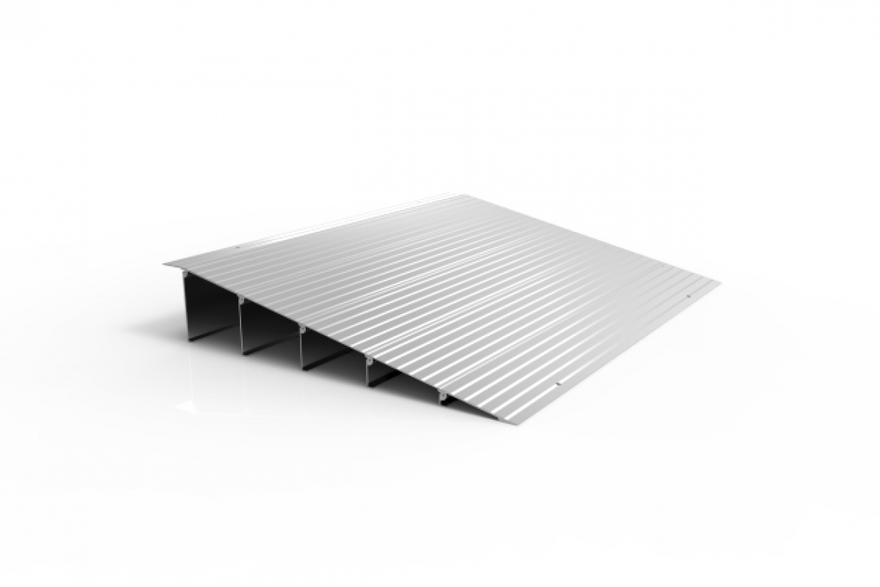

Power Ups

Perhaps something like this with a unique logo inside for each power-up. This one might be a jump boost for instance. These would be cubes with the logo inside, probably spinning to make the environment feel less static.



Finish Line

The finish line could look something like this with more shading and detail. The banner itself would be holographic so that the racers can’t accidentally bump into it. The text itself would change to show the count of the lap that the player is about to be on after they cross the line.

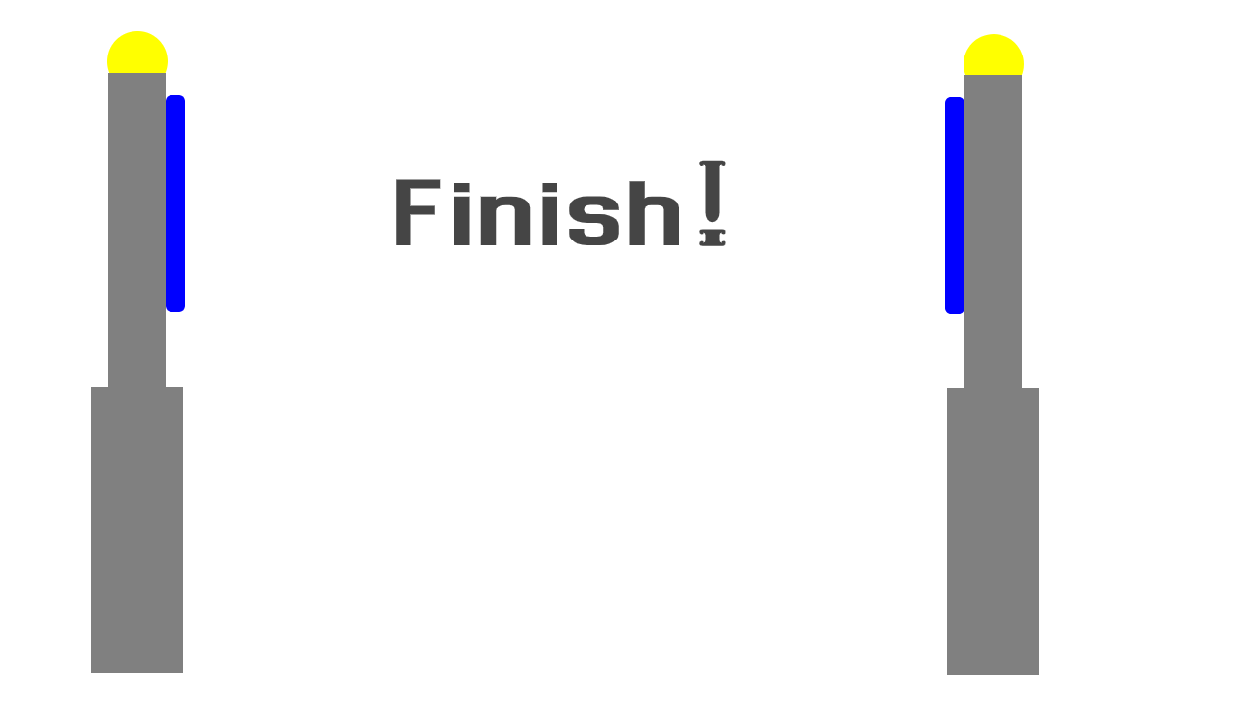

Statue

This statue is for the center of the PPP map. It is made in the likeness of the grand arbiter pineapple of course.

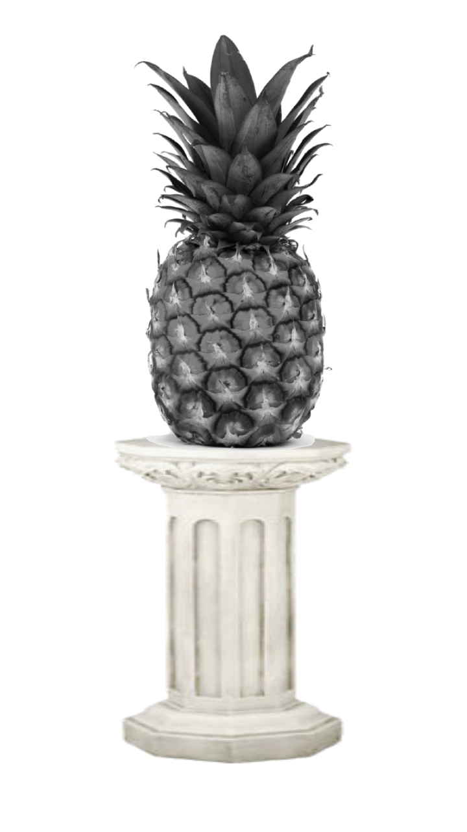

Crowd

The stands would be filled with a bunch of 2D images of these (spectators)

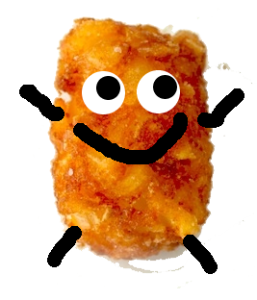

Alternate crowd

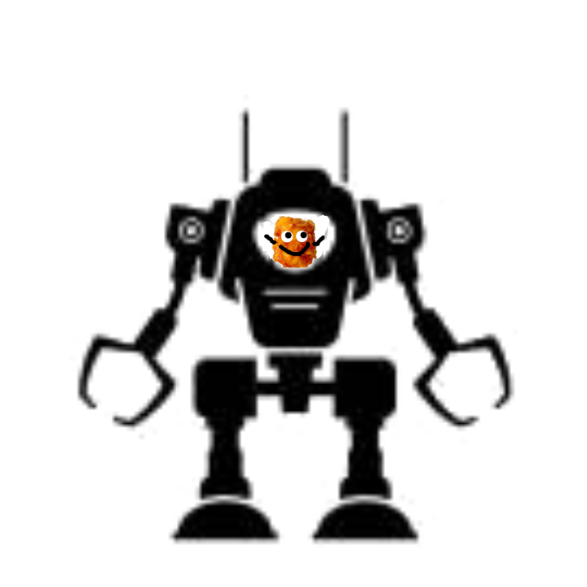

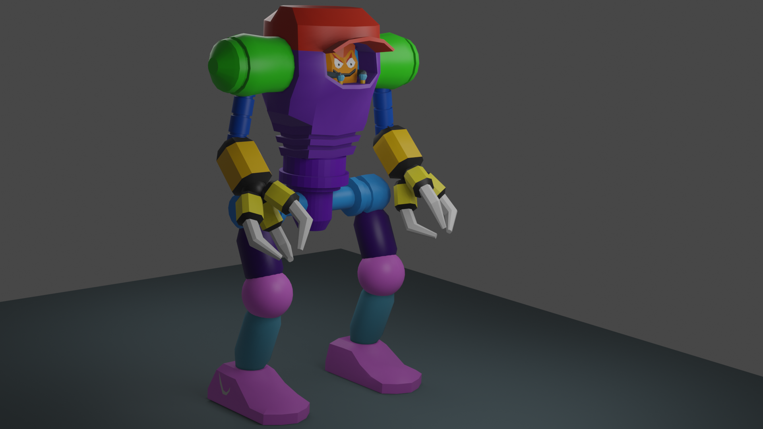

Alternate crowd 2

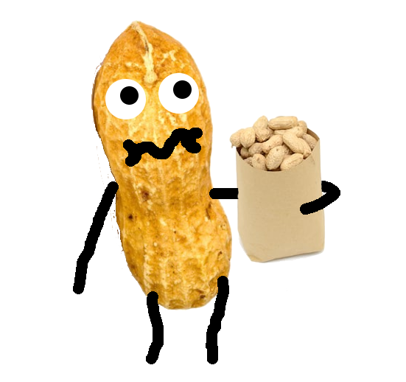

Weapons and projectiles

Spud Shot

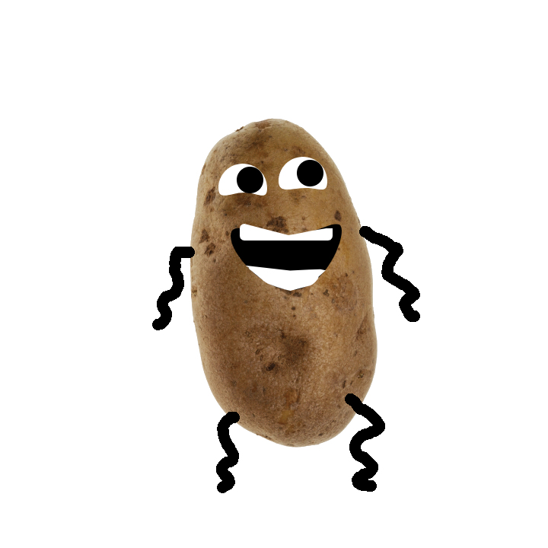

C4 Explosive

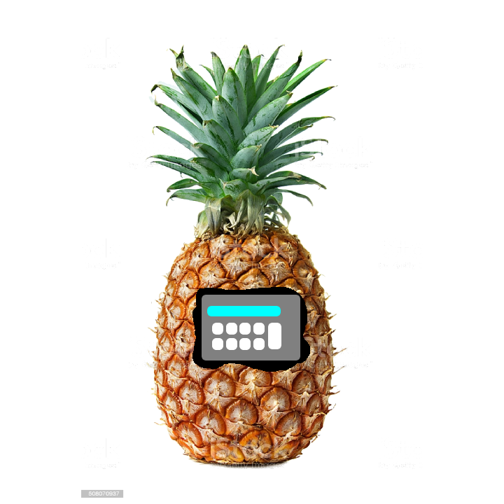

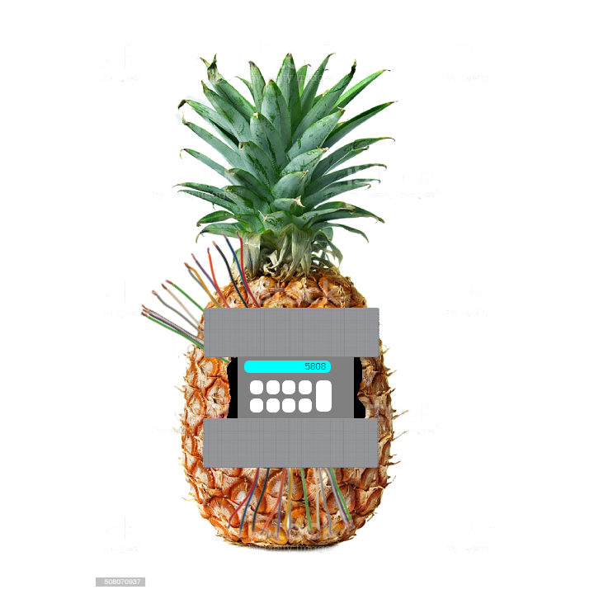

Land Mine

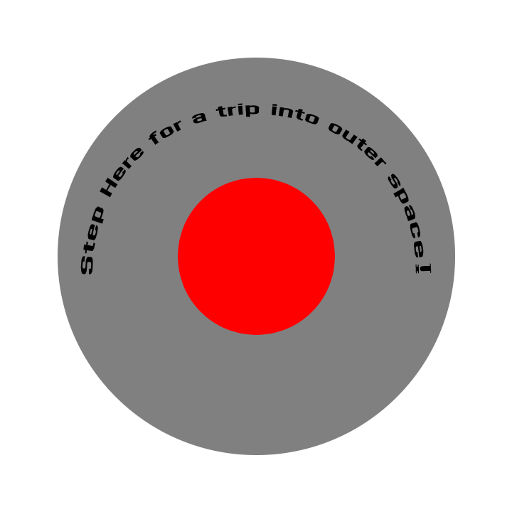

BlunderBuss

100% not a french horn as that would be illegal. Why do you ask?

